VEX IQ Level Up : Session 2 - Building Station

Activity: Build the Level Up Hero Bot, Flop
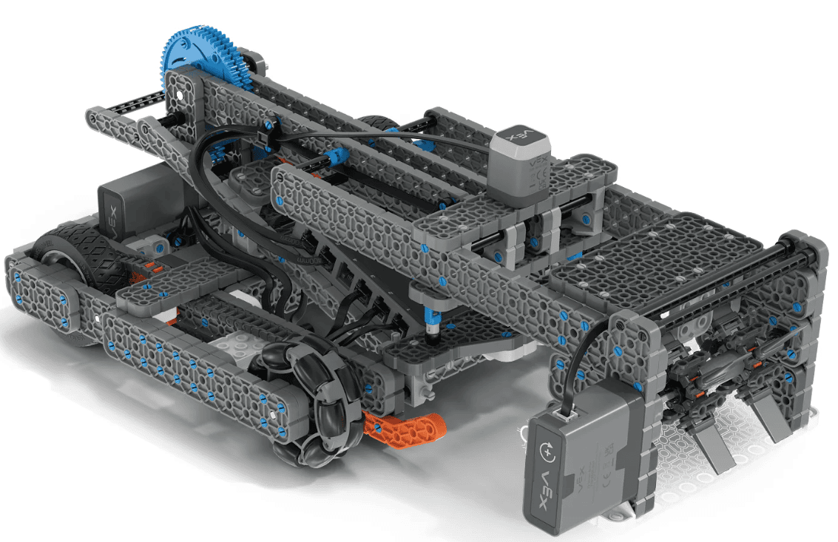
The Hero Bot, Flop, will be built in stages so each person on the team gets a chance to build. Check each and every step as it is completed in the build instructions to ensure Flop is built correctly.
Complete the build instructions based on where the previous team members left off.
Build Instructions for Flop can be found here.
- Stage 1: Steps 1 through 39
- Stage 2: Steps 40 through 79
- Stage 3: Steps 80 through 117
- Stage 4: Steps 118 through 152 and testing the robot.
Test Flop by driving the robot to pick up and place a Bean Bag in a floor goal.
    - Follow these steps to pair the Controller and Brain.
    - Then, use the Built-In Drive Program to drive Flop.
Make sure all pieces stay together and the robot moves successfully.
Feeling Stuck?
- Use the IQ Printable Parts Ruler to help you locate the correct size of pieces in the kit.
- Reference the IQ Competition Kit Parts Poster to help you as you are building.

Discussion Questions While Building  - What do you think the section of Flop you are building will do?  - What is one “pro-tip” you would give to a group building another stage of the robot?  - How do you think Flop can pick up and score Bean Bags on goals of different heights? | Activity Checklist  - Each team member built part of the robot.  - Stage 1 steps complete  - Stage 2 steps complete  - Stage 3 steps complete  - Stage 4 steps complete  - Flop drives, picks up, and scores a Bean Bag.

